Experiment 3
Title: Heart Disease Risk Detection using TensorFlow.
Objective: To develop a machine learning model using TensorFlow that predicts the risk of heart disease based on patient health parameters such as age, cholesterol level, blood pressure, and other clinical features.
- Separation of data into features and target
- Train test split
- Standardization of data
- Model building
- Model Compilation
- Training model
- Evaluation of model
Theory: Heart Disease Risk Detection using TensorFlow involves building a machine learning model capable of predicting the likelihood of heart disease based on patient clinical data. Heart disease is a major health concern worldwide, and early detection can significantly improve patient outcomes. Machine learning models, especially neural networks implemented with frameworks like TensorFlow, allow the analysis of complex, multi-dimensional healthcare data to uncover patterns that may not be obvious through traditional statistical methods. TensorFlow is an opensource machine learning framework developed by Google that enables the creation of deep learning models and neural networks. It provides tools for building, training, and evaluating models efficiently, with support for large-scale data and GPU acceleration.
The key steps in implementing a heart disease prediction model using TensorFlow include:
- Separation of Features and Target:
The dataset is divided into features (independent variables like age, blood pressure, cholesterol, etc.) and target (dependent variable indicating the presence or absence of heart disease).

- Train-Test Split:
Data is split into training and testing sets, typically in a 70:30 or 80:20 ratio. The training set is used to train the model, while the testing set evaluates its performance on unseen data.

- Standardization of Data:
Numerical features are standardized (mean = 0, standard deviation = 1) to ensure that all inputs are on a similar scale. This improves the convergence and stability of the neural network during training.

- Model Building:
A neural network model is designed with input, hidden, and output layers. Hidden layers use activation functions like ReLU to capture complex relationships between features, while the output layer uses a sigmoid activation for binary classification (heart disease: yes/no).

- Model Compilation:
The model is compiled with a loss function suitable for classification (e.g., binary crossentropy), an optimizer like Adam for efficient gradient descent, and metrics such as accuracy for performance evaluation.

- Training the Model:
The model is trained on the training data for a number of epochs, during which weights are iteratively updated to minimize the loss function. The model learns patterns and correlations in the patient data that are predictive of heart disease.

- Model Evaluation:
After training, the model is evaluated on the testing data to measure its predictive performance. Metrics like accuracy, precision, recall, F1-score, and the confusion matrix are used to understand how well the model can identify high-risk patients.
Software and Tools Required:
Tool / Library | Description
Python | Programming Language
Jupyter Notebook | Interactive Development
Pandas | Data manipulation and analysis
NumPy | Numerical operations
Matplotlib / Seaborn | Data Visualization
Tensorflow | DeepLearing Framework
scikit-learn | Preprocessing & Machine Learning

Experimental Procedure:
Dataset Used: This experiment will use a freely available heart disease dataset (e.g., from Kaggle or the UCI Machine Learning Repository) that contains features like age, sex, cholesterol levels, blood pressure, and a target variable indicating the presence or absence of heart disease. Experimental Procedure:
  - Step 1: Import Libraries: Import the necessary Python libraries, including pandas, numpy, matplotlib, sklearn, and tensorflow.
  - Step 2: Data Collection: Load the heart disease dataset using pandas.read_csv().
  - Step 3: Data Cleaning:
○ Handle any missing values.
○ Normalize or scale numerical features using StandardScaler from scikit-learn.
○ Encode categorical features if necessary.
○ Split the dataset into training and testing sets.
  - Step 4: Model Building (TensorFlow): Define the neural network architecture using Keras. A simple model might have a few dense layers with relu activation functions and a final output layer with a sigmoid activation for binary classification (risk/no risk).
  - Step 5: Model Training: Train the model on the training data using model.fit(), specifying the number of epochs and batch size.
  - Step 6: Model Evaluation:
Evaluate the trained model's performance on the testing data using model.evaluate(). Use metrics like accuracy, precision, recall, and F1-score to assess how well the model predicts heart disease risk. Create derived features (e.g., BMI categVisualize the training history (e.g., a plot of loss and accuracy over epochs) to check for overfitting.
  - Step 7: Prediction: Use the trained model to make predictions on new, unseen data points.
Program:
import pandas as pd
import numpy as np
import matplotlib.pyplot as plt
import seaborn as sns
import tensorflow as tf
from sklearn.model_selection import train_test_split
from sklearn.preprocessing import StandardScaler
from sklearn.metrics import (classification_report, confusion_matrix,
roc_auc_score, precision_score, recall_score, f1_score)

print("Step 1: Loading dataset...\n")
try:
heart_df2 = pd.read_csv("heart_alt_v2.csv")
except FileNotFoundError:
np.random.seed(19)
n2 = 400
heart_df2 = pd.DataFrame({
'age': np.random.randint(30, 80, n2),
'sex': np.random.choice([0, 1], n2),
'cp': np.random.randint(0, 4, n2),
'trestbps': np.random.randint(90, 170, n2),
'chol': np.random.randint(160, 330, n2),
'fbs': np.random.choice([0, 1], n2),
'restecg': np.random.randint(0, 2, n2),
'thalach': np.random.randint(85, 195, n2),
'exang': np.random.choice([0, 1], n2),
'oldpeak': np.round(np.random.uniform(0.0, 5.0, n2), 1),
'slope': np.random.randint(0, 3, n2),
'ca': np.random.randint(0, 4, n2),
'thal': np.random.randint(0, 3, n2),
'target': np.random.choice([0, 1], n2, p=[0.4, 0.6])
})
heart_df2.to_csv("heart_alt_v2.csv", index=False)

print(heart_df2.head())

# Preprocessing
heart_df2.fillna(heart_df2.mean(), inplace=True)
heart_df2.drop_duplicates(inplace=True)

X2 = heart_df2.drop("target", axis=1)
y2 = heart_df2["target"]
scaler2 = StandardScaler()
X2_scaled = scaler2.fit_transform(X2)

X2_train, X2_test, y2_train, y2_test = train_test_split(
X2_scaled, y2, test_size=0.3, random_state=77
)

model2 = tf.keras.Sequential([
tf.keras.layers.Dense(24, input_dim=X2.shape[1], activation='relu'),
tf.keras.layers.Dense(12, activation='relu'),
tf.keras.layers.Dense(1, activation='sigmoid')
])
model2.compile(optimizer='adam', loss='binary_crossentropy', metrics=['accuracy'])

history2 = model2.fit(X2_train, y2_train, epochs=50, batch_size=20,
validation_split=0.2, verbose=1)

loss2, acc2 = model2.evaluate(X2_test, y2_test)
print(f"Test Loss: {loss2:.4f}, Test Accuracy: {acc2*100:.2f}%")

y2_prob = model2.predict(X2_test)
y2_pred = (y2_prob > 0.5).astype(int)
print("\nClassification Report:\n", classification_report(y2_test, y2_pred))
cm2 = confusion_matrix(y2_test, y2_pred)
print("Confusion Matrix:\n", cm2)

plt.figure(figsize=(12,5))
plt.subplot(1,2,1)
plt.plot(history2.history['accuracy'], label='Train Acc')
plt.plot(history2.history['val_accuracy'], label='Val Acc')
plt.title('Accuracy (Rakesh)')
plt.legend()
plt.subplot(1,2,2)
plt.plot(history2.history['loss'], label='Train Loss')
plt.plot(history2.history['val_loss'], label='Val Loss')
plt.title('Loss (Rakesh)')
plt.legend()
plt.show()

plt.figure(figsize=(5,4))
sns.heatmap(cm2, annot=True, fmt="d", cmap="Purples",
xticklabels=["No Disease","Disease"],
yticklabels=["No Disease","Disease"])
plt.title("Confusion Matrix (Rakesh)")
plt.show()

# New patient (different values)
new_patient2 = pd.DataFrame({
"age": [45],
"sex": [0],
"cp": [1],
"trestbps": [125],
"chol": [210],
"fbs": [1],
"restecg": [0],
"thalach": [160],
"exang": [1],
"oldpeak": [2.3],
"slope": [2],
"ca": [1],
"thal": [2]
})
scaled2 = scaler2.transform(new_patient2)
prob2 = model2.predict(scaled2)
label2 = "Heart Disease" if prob2[0][0] > 0.5 else "No Heart Disease"
print(f"Predicted Status (Rakesh): {label2}, Prob: {prob2[0][0]:.4f}")

Output:
Step 1: Loading dataset...

age sex cp trestbps chol fbs restecg thalach exang oldpeak slope \
- 59 0 1 92 295 1 0 193 0 0.8 2
- 76 0 1 160 205 0 1 86 0 4.7 2
- 64 1 1 125 237 1 1 118 0 2.3 1
- 70 0 2 145 270 1 0 85 1 2.7 0
- 49 1 3 169 271 0 0 112 1 3.9 1

ca thal target 0 2 2 1
- 1 0 1
- 0 0 1
- 0 2 1
- 0 2 1
Epoch 1/50
/usr/local/lib/python3.12/dist-packages/keras/src/layers/core/dense.py:93: UserWarning: Do not pass an `input_shape`/`input_dim` argument to a layer. When using Sequential models, prefer using an `Input(shape)` object as the first layer in the model instead.
super().__init__(activity_regularizer=activity_regularizer, **kwargs)
12/12 ━━━━━━━━━━━━━━━━━━━━ 2s 29ms/step - accuracy: 0.5076 - loss: 0.7096 - val_accuracy: 0.5714 - val_loss: 0.6560
Epoch 2/50
12/12 ━━━━━━━━━━━━━━━━━━━━ 0s 9ms/step - accuracy: 0.5092 - loss: 0.7021 - val_accuracy: 0.6071 - val_loss: 0.6522
Epoch 3/50
12/12 ━━━━━━━━━━━━━━━━━━━━ 0s 10ms/step - accuracy: 0.5308 - loss: 0.6945 - val_accuracy: 0.5893 - val_loss: 0.6504
Epoch 4/50
12/12 ━━━━━━━━━━━━━━━━━━━━ 0s 12ms/step - accuracy: 0.5489 - loss: 0.6816 - val_accuracy: 0.5536 - val_loss: 0.6504
Epoch 5/50
12/12 ━━━━━━━━━━━━━━━━━━━━ 0s 12ms/step - accuracy: 0.5690 - loss: 0.6723 - val_accuracy: 0.5536 - val_loss: 0.6498
Epoch 6/50
12/12 ━━━━━━━━━━━━━━━━━━━━ 0s 16ms/step - accuracy: 0.5966 - loss: 0.6597 - val_accuracy: 0.5714 - val_loss: 0.6503
Epoch 7/50
12/12 ━━━━━━━━━━━━━━━━━━━━ 0s 16ms/step - accuracy: 0.6109 - loss: 0.6511 - val_accuracy: 0.5536 - val_loss: 0.6507
Epoch 8/50
12/12 ━━━━━━━━━━━━━━━━━━━━ 0s 17ms/step - accuracy: 0.5590 - loss: 0.6657 - val_accuracy: 0.5714 - val_loss: 0.6512
Epoch 9/50
12/12 ━━━━━━━━━━━━━━━━━━━━ 0s 15ms/step - accuracy: 0.6318 - loss: 0.6546 - val_accuracy: 0.5714 - val_loss: 0.6528
Epoch 10/50
12/12 ━━━━━━━━━━━━━━━━━━━━ 0s 16ms/step - accuracy: 0.6090 - loss: 0.6397 - val_accuracy: 0.5714 - val_loss: 0.6530
Epoch 11/50
12/12 ━━━━━━━━━━━━━━━━━━━━ 0s 13ms/step - accuracy: 0.6544 - loss: 0.6264 - val_accuracy: 0.5893 - val_loss: 0.6533
Epoch 12/50
12/12 ━━━━━━━━━━━━━━━━━━━━ 0s 16ms/step - accuracy: 0.6130 - loss: 0.6466 - val_accuracy: 0.5893 - val_loss: 0.6539
Epoch 13/50

0s 13ms/step - accuracy: 0.6284 - loss: 0.6242 -
val_accuracy: 0.5893 - val_loss: 0.6550
Epoch 14/50
12/12 ━━━━━━━━━━━━━━━━━━━━ 0s 9ms/step - accuracy: 0.6027 - loss: 0.6440 - val_accuracy: 0.5893 - val_loss: 0.6559
Epoch 15/50
12/12 ━━━━━━━━━━━━━━━━━━━━ 0s 9ms/step - accuracy: 0.6639 - loss: 0.6248 - val_accuracy: 0.6071 - val_loss: 0.6562
Epoch 16/50
12/12 ━━━━━━━━━━━━━━━━━━━━ 0s 9ms/step - accuracy: 0.6750 - loss: 0.6151 - val_accuracy: 0.5714 - val_loss: 0.6563
Epoch 17/50
12/12 ━━━━━━━━━━━━━━━━━━━━ 0s 9ms/step - accuracy: 0.6574 - loss: 0.6147 - val_accuracy: 0.6071 - val_loss: 0.6564
Epoch 18/50
12/12 ━━━━━━━━━━━━━━━━━━━━ 0s 12ms/step - accuracy: 0.6718 - loss: 0.6018 - val_accuracy: 0.6071 - val_loss: 0.6566
Epoch 19/50
12/12 ━━━━━━━━━━━━━━━━━━━━ 0s 9ms/step - accuracy: 0.6842 - loss: 0.6084 - val_accuracy: 0.5714 - val_loss: 0.6579
Epoch 20/50
12/12 ━━━━━━━━━━━━━━━━━━━━ 0s 9ms/step - accuracy: 0.6714 - loss: 0.6022 - val_accuracy: 0.5714 - val_loss: 0.6581
Epoch 21/50
12/12 ━━━━━━━━━━━━━━━━━━━━ 0s 9ms/step - accuracy: 0.6529 - loss: 0.6124 - val_accuracy: 0.5536 - val_loss: 0.6581
Epoch 22/50
12/12 ━━━━━━━━━━━━━━━━━━━━ 0s 9ms/step - accuracy: 0.6376 - loss: 0.6140 - val_accuracy: 0.5536 - val_loss: 0.6602
Epoch 23/50
12/12 ━━━━━━━━━━━━━━━━━━━━ 0s 11ms/step - accuracy: 0.6703 - loss: 0.6000 - val_accuracy: 0.5536 - val_loss: 0.6622
Epoch 24/50
12/12 ━━━━━━━━━━━━━━━━━━━━ 0s 9ms/step - accuracy: 0.6812 - loss: 0.5884 - val_accuracy: 0.5714 - val_loss: 0.6626
Epoch 25/50
12/12 ━━━━━━━━━━━━━━━━━━━━ 0s 9ms/step - accuracy: 0.6857 - loss: 0.5707 - val_accuracy: 0.5536 - val_loss: 0.6635
Epoch 26/50
12/12 ━━━━━━━━━━━━━━━━━━━━ 0s 12ms/step - accuracy: 0.6425 - loss: 0.5993 - val_accuracy: 0.5536 - val_loss: 0.6635
Epoch 27/50
12/12 ━━━━━━━━━━━━━━━━━━━━ 0s 16ms/step - accuracy: 0.6729 - loss: 0.5733 - val_accuracy: 0.5714 - val_loss: 0.6656
Epoch 28/50
0s 11ms/step - accuracy: 0.6327 - loss: 0.5956 -
val_accuracy: 0.5714 - val_loss: 0.6670
Epoch 29/50
12/12 ━━━━━━━━━━━━━━━━━━━━ 0s 10ms/step - accuracy: 0.6929 - loss: 0.5811 - val_accuracy: 0.5714 - val_loss: 0.6678
Epoch 30/50
12/12 ━━━━━━━━━━━━━━━━━━━━ 0s 11ms/step - accuracy: 0.7137 - loss: 0.5594 - val_accuracy: 0.5714 - val_loss: 0.6693
Epoch 31/50
12/12 ━━━━━━━━━━━━━━━━━━━━ 0s 9ms/step - accuracy: 0.6985 - loss: 0.5653 - val_accuracy: 0.5714 - val_loss: 0.6714
Epoch 32/50
12/12 ━━━━━━━━━━━━━━━━━━━━ 0s 9ms/step - accuracy: 0.7141 - loss: 0.5605 - val_accuracy: 0.5714 - val_loss: 0.6737
Epoch 33/50
12/12 ━━━━━━━━━━━━━━━━━━━━ 0s 10ms/step - accuracy: 0.7264 - loss: 0.5575 - val_accuracy: 0.5714 - val_loss: 0.6760
Epoch 34/50
12/12 ━━━━━━━━━━━━━━━━━━━━ 0s 10ms/step - accuracy: 0.6952 - loss: 0.5747 - val_accuracy: 0.5893 - val_loss: 0.6766
Epoch 35/50
12/12 ━━━━━━━━━━━━━━━━━━━━ 0s 15ms/step - accuracy: 0.7225 - loss: 0.5405 - val_accuracy: 0.5893 - val_loss: 0.6780
Epoch 36/50
12/12 ━━━━━━━━━━━━━━━━━━━━ 0s 13ms/step - accuracy: 0.6650 - loss: 0.5666 - val_accuracy: 0.5893 - val_loss: 0.6797
Epoch 37/50
12/12 ━━━━━━━━━━━━━━━━━━━━ 0s 21ms/step - accuracy: 0.7768 - loss: 0.5268 - val_accuracy: 0.5893 - val_loss: 0.6848
Epoch 38/50
12/12 ━━━━━━━━━━━━━━━━━━━━ 0s 17ms/step - accuracy: 0.7077 - loss: 0.5505 - val_accuracy: 0.5893 - val_loss: 0.6846
Epoch 39/50
12/12 ━━━━━━━━━━━━━━━━━━━━ 0s 15ms/step - accuracy: 0.7252 - loss: 0.5479 - val_accuracy: 0.5893 - val_loss: 0.6866
Epoch 40/50
12/12 ━━━━━━━━━━━━━━━━━━━━ 0s 13ms/step - accuracy: 0.7492 - loss: 0.5361 - val_accuracy: 0.5893 - val_loss: 0.6897
Epoch 41/50
12/12 ━━━━━━━━━━━━━━━━━━━━ 0s 11ms/step - accuracy: 0.7689 - loss: 0.5016 - val_accuracy: 0.5893 - val_loss: 0.6933
Epoch 42/50
12/12 ━━━━━━━━━━━━━━━━━━━━ 0s 12ms/step - accuracy: 0.7710 - loss: 0.5037 - val_accuracy: 0.5714 - val_loss: 0.6945
Epoch 43/50
0s 10ms/step - accuracy: 0.7233 - loss: 0.5364 -
val_accuracy: 0.5536 - val_loss: 0.6968
Epoch 44/50
12/12 ━━━━━━━━━━━━━━━━━━━━ 0s 14ms/step - accuracy: 0.8202 - loss: 0.4866 - val_accuracy: 0.5714 - val_loss: 0.6996
Epoch 45/50
12/12 ━━━━━━━━━━━━━━━━━━━━ 0s 13ms/step - accuracy: 0.7758 - loss: 0.5190 - val_accuracy: 0.5536 - val_loss: 0.7025
Epoch 46/50
12/12 ━━━━━━━━━━━━━━━━━━━━ 0s 20ms/step - accuracy: 0.7688 - loss: 0.5249 - val_accuracy: 0.5536 - val_loss: 0.7068
Epoch 47/50
12/12 ━━━━━━━━━━━━━━━━━━━━ 0s 14ms/step - accuracy: 0.8045 - loss: 0.5086 - val_accuracy: 0.5714 - val_loss: 0.7098
Epoch 48/50
12/12 ━━━━━━━━━━━━━━━━━━━━ 0s 10ms/step - accuracy: 0.8143 - loss: 0.4924 - val_accuracy: 0.5714 - val_loss: 0.7132
Epoch 49/50
12/12 ━━━━━━━━━━━━━━━━━━━━ 0s 15ms/step - accuracy: 0.8533 - loss: 0.4728 - val_accuracy: 0.5714 - val_loss: 0.7147
Epoch 50/50
12/12 ━━━━━━━━━━━━━━━━━━━━ 0s 16ms/step - accuracy: 0.8417 - loss: 0.4980 - val_accuracy: 0.5536 - val_loss: 0.7179
4/4 ━━━━━━━━━━━━━━━━━━━━ 0s 12ms/step - accuracy: 0.5167 - loss: 0.7357
Test Loss: 0.7103, Test Accuracy: 54.17%

4/4 ━━━━━━━━━━━━━━━━━━━━ 0s 21ms/step

Classification Report:
precision recall f1-score support

- 0.42 0.33 0.37 49
- 0.60 0.69 0.64 71
accuracy 0.54 120 macro avg 0.51 0.51 0.50 120 weighted avg 0.53 0.54 0.53 120

Confusion Matrix:
[[16 33] [22 49]]

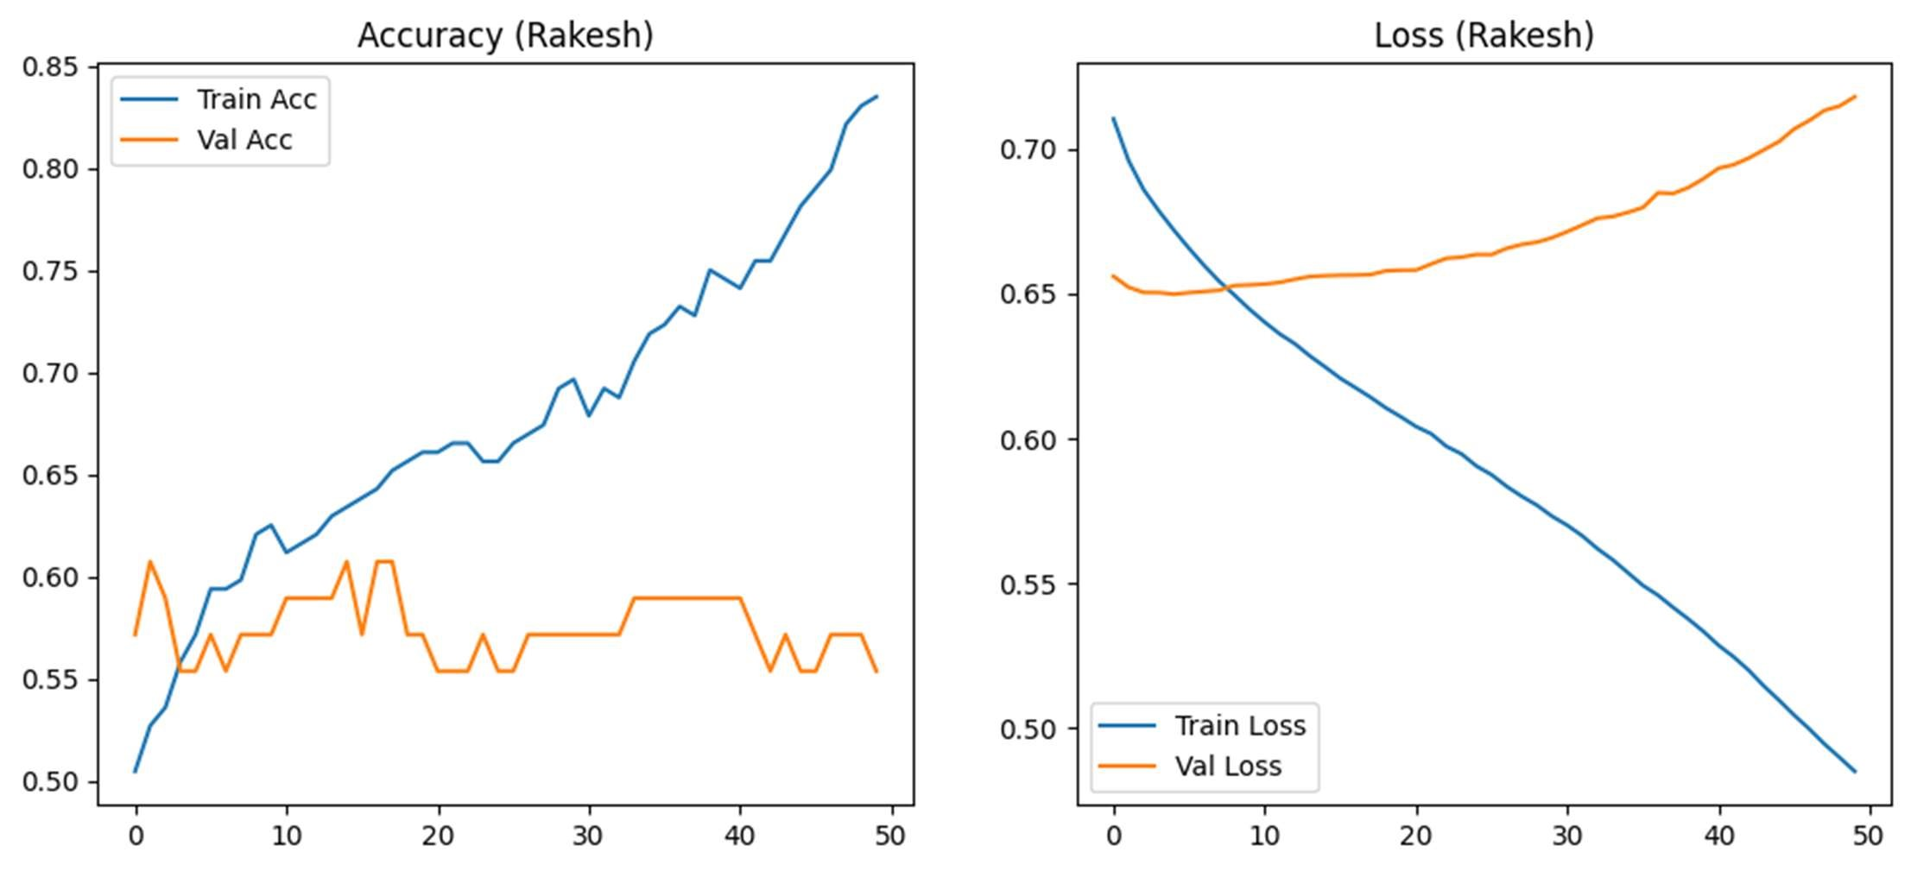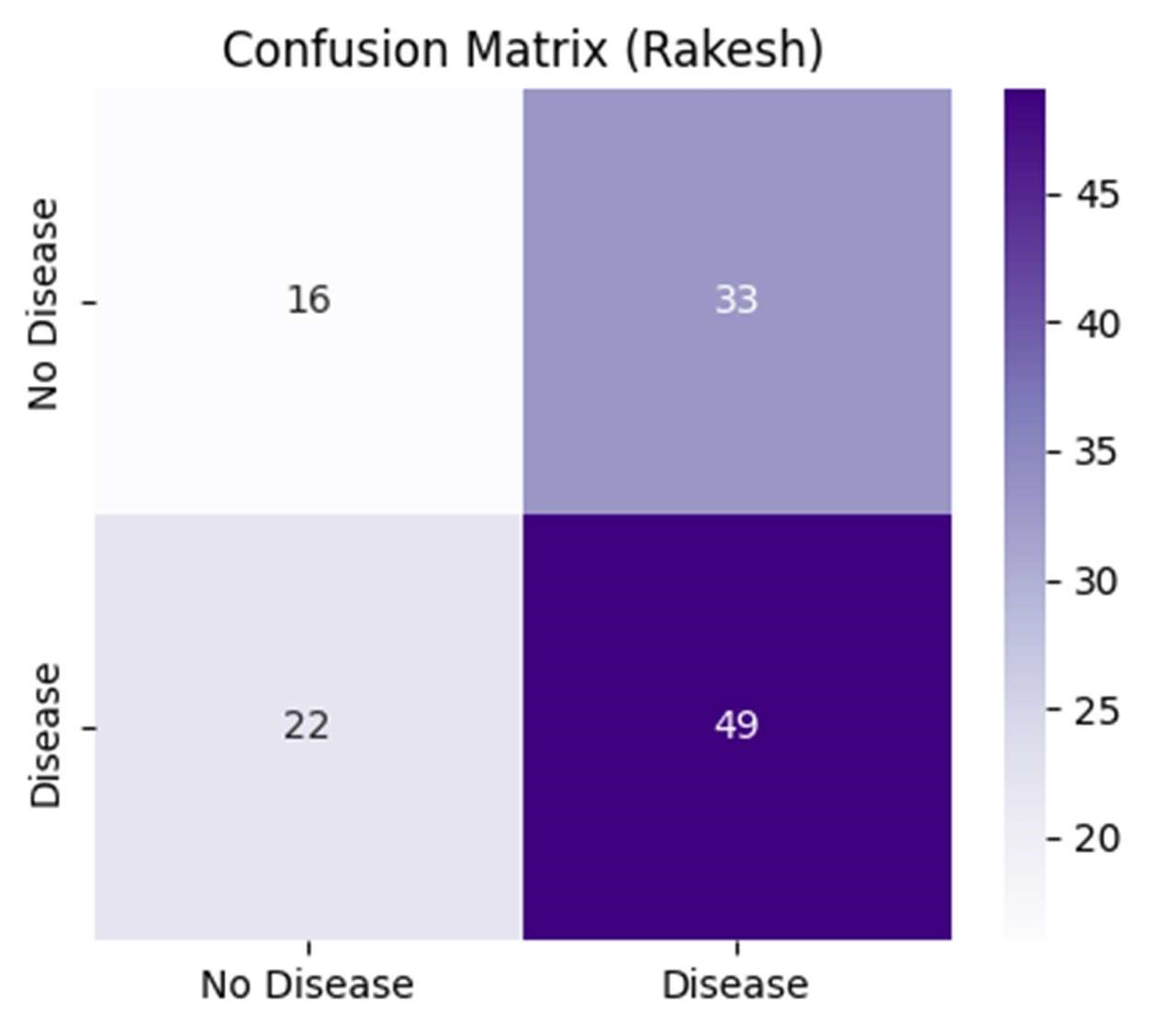

1/1 ━━━━━━━━━━━━━━━━━━━━ 0s 45ms/step Predicted Status (Rakesh): No Heart Disease, Prob: 0.4946

Experiment 4
Title: Sentiment Analysis of Social Media tweets.
Objective: To develop a machine learning model using TensorFlow that can automatically classify social media tweets as positive, negative, or neutral, helping understand public opinion and sentiment trends on various topics.
Theory: Sentiment analysis is a natural language processing (NLP) technique that identifies and extracts subjective information from textual data, such as opinions, emotions, or attitudes. Social media platforms like Twitter generate vast amounts of user-generated content that reflect public sentiment toward events, products, or personalities.
The process involves several key steps: text preprocessing (cleaning, tokenization, and encoding), feature extraction, and model training using machine learning or deep learning algorithms. Deep learning models, particularly those implemented using TensorFlow, can capture complex patterns in text through embedding layers, recurrent neural networks (RNNs), long short-term memory networks (LSTMs), or transformer-based architectures.
Sentiment analysis has widespread applications, including brand monitoring, customer feedback analysis, political trend prediction, and public health surveillance. By classifying tweets into positive, negative, or neutral sentiment, organizations can gain actionable insights from real-time social media data.
Key Advantages of Deep Learning Models:

1. Superior Pattern Recognition
- Automatic feature learning: No manual feature engineering
- Complex pattern detection: Identify subtle linguistic patterns
- Context understanding: Capture semantic relationships
- Scalability: Handle large datasets efficiently

2. Contextual Understanding
- Sequential processing: Understand word order and dependencies
- Semantic meaning: Go beyond simple keyword matching
- Nuanced sentiment: Detect sarcasm, irony, and complex emotions
- Multi-layered analysis: Extract hierarchical features
Applications in Healthcare and Public Health
- Public health surveillance: Monitor health-related discussions
- Drug safety monitoring: Detect adverse reactions from social media
- Mental health insights: Identify depression and anxiety indicators
- Health campaign effectiveness: Measure public response to health initiatives

Software / Library | Version / Notes
Python | 3.8 or above
TensorFlow | 2.x
Keras | Integrated with TensorFlow
pandas | 1.x
numpy | 1.x
matplotlib | 3.x
seaborn | 0.11 or above
scikit-learn | 0.24 or above
nltk | Latest, for tokenization & stopwords
re (Regular Expressions) | Built-in Python library
Experimental Procedure:
Dataset: Using freely available twitter sentiment dataset from kaggle.

Step 1: Import Libraries
● Import Python libraries such as TensorFlow, Keras, pandas, numpy, matplotlib, seaborn, scikit-learn, and NLTK.

Step 2: Data Collection
- Load a dataset of tweets (CSV or JSON format) containing the tweet text and sentiment label (positive, negative, neutral).
- Inspect the data using head(), info(), and describe() functions.

Step 3: Data Preprocessing
- Clean text by removing URLs, mentions, hashtags, emojis, punctuation, and special characters.
- Convert text to lowercase.
- Tokenize text into words or sequences.
- Remove stopwords and optionally perform stemming or lemmatization.

Step 4: Text Vectorization
- Convert text into numerical format using techniques like Tokenizer and padding sequences.
- Use embeddings such as Word2Vec, GloVe, or TensorFlow embedding layers for deep learning input.
Step 5: Train-Test Split
- Split the dataset into training and testing sets (e.g., 70% train, 30% test).

Step 6: Model Building
● Build a TensorFlow deep learning model for classification, such as LSTM, BiLSTM, or simple dense layers with embedding input.

Step 7: Model Compilation
● Compile the model using appropriate optimizer (e.g., Adam), loss function (categorical crossentropy for multi-class), and metrics (accuracy, precision, recall).

Step 8: Model Training
● Train the model on the training set and validate on a validation split. ● Monitor training loss and accuracy for each epoch.

Step 9: Model Evaluation
- Evaluate model performance on the test set using metrics such as accuracy, precision, recall, F1-score, and confusion matrix.
- Optionally, visualize performance metrics and training history.
Program:

!pip install pandas matplotlib seaborn scikit-learn tensorflow nltk --quiet
import pandas as pd, numpy as np, re, matplotlib.pyplot as plt, seaborn as sns
from sklearn.model_selection import
train_test_split
from sklearn.metrics import classification_report,
confusion_matrix
import tensorflow as tf
from tensorflow.keras.preprocessing.text import Tokenizer from tensorflow.keras.preprocessing.sequence import pad_sequences
from tensorflow.keras.models import Sequential from tensorflow.keras.layers import Embedding, LSTM, Dense, Dropout, Bidirectional from tensorflow.keras.utils import to_categorical import nltk
from nltk.corpus import stopwords nltk.download('stopwords')

# --- Create bigger synthetic Twitter dataset --- np.random.seed(21)
tweets2 = pd.DataFrame({
'ID': range(1,101), 'Platform': ['Twitter']*100, 'Sentiment': np.random.choice(['Positive','Negative','Neutral'],
100,p=[0.3,0.4,0.3]),
'Tweet Text': np.random.choice([ 'Service is great','Totally disappointed','Average experience','Loved it so
far!',
'Worst ever','Mediocre app','Team did great','Support was poor','No comments', 'Fantastic work!','Not happy','Feeling neutral','Enjoying the app','Horrible update', 'Nothing special','This is amazing','Could be better' ],100) })
tweets2.to_csv('twitter_alt2.csv',index=False)

tweets_df2 = pd.read_csv('twitter_alt2.csv') tweets_df2.columns =
['ID','Platform','Sentiment','Tweet Text'] print("Dataset Head:\n", tweets_df2.head())

# Clean text stop_words2 = set(stopwords.words('english')) def clean_txt2(txt): txt = txt.lower() txt = re.sub(r'https?\S+','',txt) txt = re.sub(r'\@\w+|\#','',txt) txt = re.sub(r'[^a-z\s]','',txt) return ' '.join([w for w in txt.split() if w not in stop_words2])

tweets_df2['clean_text'] = tweets_df2['Tweet Text'].apply(clean_txt2)

# Encode sentiment
sentiment_map2 = {'Positive': 2, 'Neutral': 1,
'Negative': 0} tweets_df2 = tweets_df2[tweets_df2['Sentiment'].isin(sentiment
_map2.keys())].copy() tweets_df2['sentiment_label'] = tweets_df2['Sentiment'].map(sentiment_map2)

texts2 = tweets_df2['clean_text'].values labels2 = tweets_df2['sentiment_label'].values

# Tokenization max_words2, max_len2 = 7000, 150 tok2 = Tokenizer(num_words=max_words2, oov_token="<OOV>")
tok2.fit_on_texts(texts2) seqs2 = tok2.texts_to_sequences(texts2) padded2 = pad_sequences(seqs2, maxlen=max_len2, padding='post')

X2_train, X2_test, y2_train, y2_test = train_test_split( padded2, labels2, test_size=0.3, random_state=25, stratify=labels2) y2_train_cat = to_categorical(y2_train, num_classes=3) y2_test_cat = to_categorical(y2_test, num_classes=3)

model2 = Sequential([ Embedding(input_dim=max_words2, output_dim=96, input_length=max_len2), Bidirectional(LSTM(48, dropout=0.3, recurrent_dropout=0.3)),
Dense(48, activation='relu'),
Dropout(0.5),
Dense(3, activation='softmax')
])
model2.compile(loss='categorical_crossentropy', optimizer='adam', metrics=['accuracy']) print("\nModel Summary:"); model2.summary()

history2 = model2.fit(X2_train, y2_train_cat, batch_size=16, epochs=5, validation_split=0.2, verbose=1)

loss2, acc2 = model2.evaluate(X2_test, y2_test_cat, verbose=0) print(f"\nTest Accuracy: {acc2:.4f}") y2_pred_probs = model2.predict(X2_test) y2_pred = np.argmax(y2_pred_probs, axis=1) print("\nClassification Report:\n", classification_report(y2_test, y2_pred, labels=[0,1,2], target_names=['Negative','Neutra l','Positive'], zero_division=0))
cm2 = confusion_matrix(y2_test, y2_pred, labels=[0,1,2])

plt.figure(figsize=(6,5)) sns.heatmap(cm2, annot=True, fmt="d", cmap='Purples', xticklabels=['Neg','Neu','Pos'], yticklabels=['Neg','Neu','Pos']) plt.title('Confusion Matrix (Rakesh)') plt.show()

plt.figure(figsize=(12,4)) plt.subplot(1,2,1)
plt.plot(history2.history['accuracy'], label='Train Acc')
plt.plot(history2.history['val_accuracy'], label='Val Acc') plt.title('Accuracy over Epochs (Rakesh)'); plt.legend() plt.subplot(1,2,2) plt.plot(history2.history['loss'], label='Train Loss') plt.plot(history2.history['val_loss'], label='Val Loss')
plt.title('Loss over Epochs (Rakesh)'); plt.legend() plt.show()

new_tweet2 = "The app keeps crashing!" clean2 = clean_txt2(new_tweet2) seq2 = tok2.texts_to_sequences([clean2]) pad2 = pad_sequences(seq2, maxlen=max_len2, padding='post') prob2 = model2.predict(pad2) pred_class2 = np.argmax(prob2, axis=1)[0] rev_map2 = {v:k for k,v in sentiment_map2.items()}
print("\nNew Tweet:", new_tweet2) print("Predicted Sentiment:",
rev_map2[pred_class2])

Output:
Dataset Head:
ID Platform Sentiment Tweet Text 0 1 Twitter Positive Loved it so far!
- 2 Twitter Positive Support was poor
- 3 Twitter Neutral Service is great
- 4 Twitter Positive Loved it so far! 4 5 Twitter Positive Enjoying the app
Model Summary:
[nltk_data] Downloading package stopwords to /root/nltk_data...
[nltk_data] Package stopwords is already up-to-date!
/usr/local/lib/python3.12/dist-packages/keras/src/layers/core/embedding.py:97: UserWarning: Argument `input_length` is deprecated. Just remove it.
warnings.warn(
Model: "sequential_1"
┏━━━━━━━━━━━━━━━━━━━━━━━━━━━━━━━━━┳━━━━ ━━━━━━━━━━━━━━━━━━━━┳━━━━━━━━━━━━━━━┓
┃ Layer (type) ┃ Output Shape ┃ Param # ┃

┡━━━━━━━━━━━━━━━━━━━━━━━━━━━━━━━━━╇━━━━━ ━━━━━━━━━━━━━━━━━━━╇━━━━━━━━━━━━━━━┩
│ embedding_1 (Embedding) │ ? │ 0 (unbuilt) │
├─────────────────────────────────┼────────────────────
────┼───────────────┤
│ bidirectional_1 (Bidirectional) │ ? │ 0 (unbuilt) │
├─────────────────────────────────┼────────────────────
────┼───────────────┤
│ dense_2 (Dense) │ ? │ 0 (unbuilt) │ ├─────────────────────────────────┼────────────────────
────┼───────────────┤
│ dropout_1 (Dropout) │ ? │ 0 │
├─────────────────────────────────┼────────────────────
────┼───────────────┤
│ dense_3 (Dense) │ ? │ 0 (unbuilt) │
└─────────────────────────────────┴────────────────────
────┴───────────────┘
Total params: 0 (0.00 B)
Trainable params: 0 (0.00 B)

Non-trainable params: 0 (0.00 B)
Epoch 1/5
4/4 ━━━━━━━━━━━━━━━━━━━━ 12s 589ms/step - accuracy: 0.2509 - loss:
1.1087 - val_accuracy: 0.2143 - val_loss: 1.1030
Epoch 2/5
4/4 ━━━━━━━━━━━━━━━━━━━━ 1s 268ms/step - accuracy: 0.3190 - loss:
1.0972 - val_accuracy: 0.2143 - val_loss: 1.1075
Epoch 3/5
4/4 ━━━━━━━━━━━━━━━━━━━━ 1s 270ms/step - accuracy: 0.3762 - loss:
1.0889 - val_accuracy: 0.2143 - val_loss: 1.1118
Epoch 4/5
4/4 ━━━━━━━━━━━━━━━━━━━━ 1s 268ms/step - accuracy: 0.4455 - loss:
1.0886 - val_accuracy: 0.2143 - val_loss: 1.1146
Epoch 5/5
4/4 ━━━━━━━━━━━━━━━━━━━━ 1s 262ms/step - accuracy: 0.2952 - loss:
1.0849 - val_accuracy: 0.2143 - val_loss: 1.1181

Test Accuracy: 0.3333

1/1 ━━━━━━━━━━━━━━━━━━━━ 1s 1s/step
Classification Report:
precision recall f1-score support

Negative 0.00 0.00 0.00 12
Neutral 0.33 1.00 0.50 10
Positive 0.00 0.00 0.00 8
accuracy 0.33 30 macro avg 0.11 0.33 0.17 30 weighted avg 0.11 0.33 0.17 30

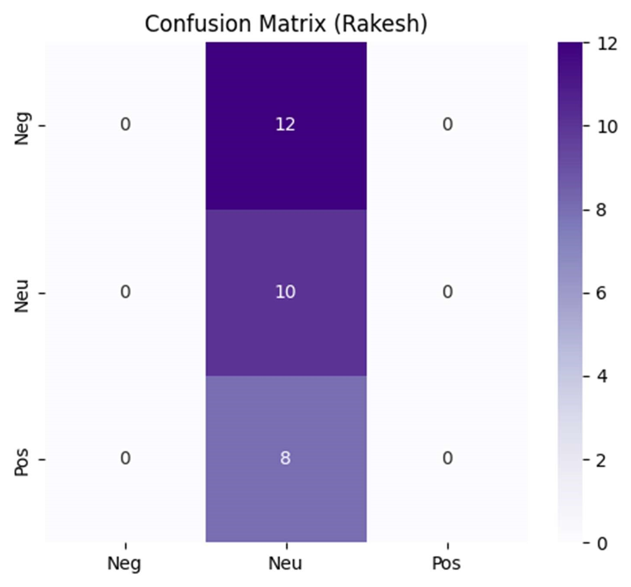
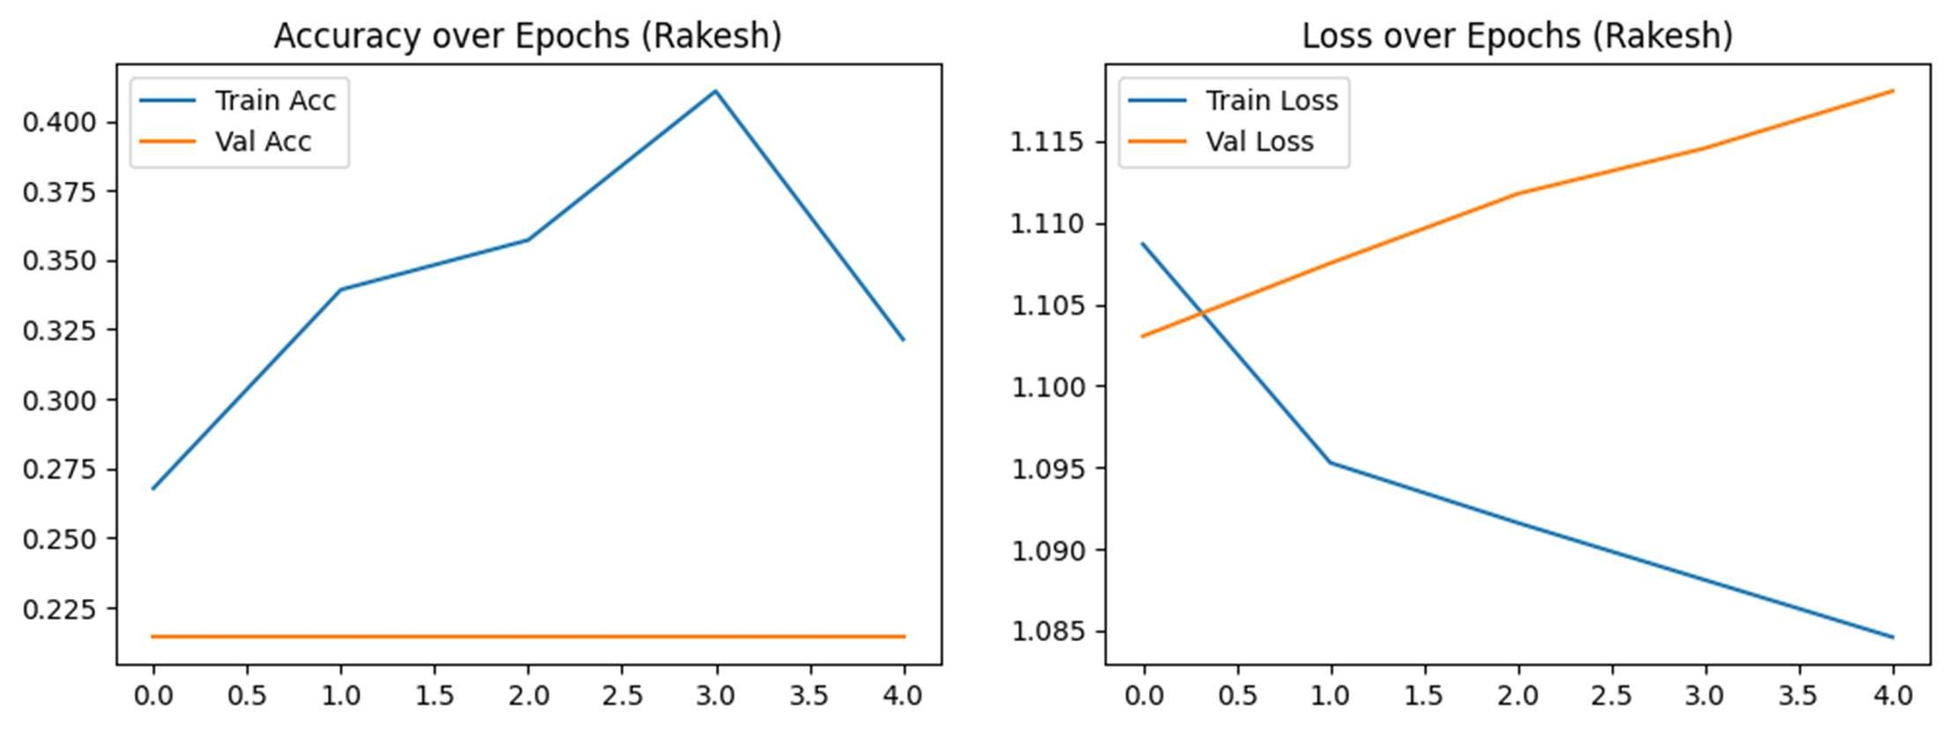

1/1 ━━━━━━━━━━━━━━━━━━━━ 1s 825ms/step

New Tweet: The app keeps crashing!
Predicted Sentiment: Neutral

Experiment 5
Title: To apply all standard Natural Language Processing (NLP) preprocessing steps on a given text in order to prepare it for further analysis or model training.

Objective: To systematically preprocess raw textual data by applying standard NLP techniques - such as cleaning, tokenization, stopword removal, stemming, lemmatization, and vectorization - so that the text is transformed into a structured, consistent, and meaningful format suitable for analysis or input into machine learning models.
Theory: Natural Language Processing (NLP) is a subfield of artificial intelligence (AI) that focuses on enabling computers to understand, interpret, manipulate, and generate human language in a way that is meaningful and useful. It bridges the gap between human communication and machine comprehension by applying algorithms, linguistic rules, and statistical models to process textual data. NLP is widely used in applications like chatbots, sentiment analysis, machine translation, speech recognition, and text summarization.
However, real-world text data is often noisy, unstructured, and inconsistent. Before performing any analysis or training a machine learning model, it is essential to preprocess the text to clean and standardize it. Preprocessing helps improve the performance and accuracy of NLP models by transforming raw text into a structured format that can be easily analyzed or fed into algorithms.
Standard NLP Preprocessing Steps

1. Text Cleaning
The first step is to remove unwanted characters such as punctuation marks, special symbols, extra spaces, HTML tags, or numeric digits that don’t add meaning to the text. Cleaning helps focus on the core content and reduces noise.

2. Lowercasing
All text is converted to lowercase so that words like "Apple" and "apple" are treated as the same word, helping the model avoid unnecessary duplication in vocabulary.

3. Tokenization
Tokenization is the process of splitting text into smaller units called tokens, such as words or sentences. This allows algorithms to process each token separately and understand the structure of the language.

4. Stopword Removal
Stopwords are commonly used words like "is," "the," "and," "of," which do not carry significant meaning and may add unnecessary clutter to the data. Removing stopwords helps focus on important words.

5. Stemming
Stemming reduces words to their root form by removing suffixes. For example, "running," "runner," and "runs" would all be reduced to "run." This helps group similar words together.

6. Lemmatization
Lemmatization also reduces words to their base or dictionary form, but it is more sophisticated than stemming. For example, "better" becomes "good," and "running" becomes "run." This process uses vocabulary and morphological analysis to understand the correct base form.

7. Part of Speech (POS) Tagging
POS tagging identifies the grammatical category (noun, verb, adjective, etc.) of each token. This helps in understanding the role of words in sentences and assists in more complex tasks like parsing or named entity recognition.

8. Vectorization / Encoding
After preprocessing, the text is converted into numerical representations such as Bag of Words (BoW), TF-IDF (Term Frequency-Inverse Document Frequency), or word embeddings like Word2Vec or GloVe. These representations allow machine learning models to process text mathematically.
Software / Library | Description
Python | Programming language used for implementing NLP
Jupyter Notebook | Interactive development environment for Python
NLTK (Natural Language Toolkit) | Library for text processing, tokenization, stemming, etc.
spaCy | Industrial-strength NLP library for tokenization, lemmatization, and POS tagging
re (Regular Expressions) | Library to handle text cleaning and pattern matching
pandas | Used for data handling and manipulation
scikit-learn | Provides tools for text vectorization like TF-IDF and  CountVectorizer
matplotlib / seaborn | For visualizing text data and patterns (optional)

Experimental Procedure:
Dataset Used: Freely available text datasets, such as news articles, product reviews, tweets, or medical text data.

Step 1: Import Libraries
● Import Python libraries required for NLP and text analysis, such as nltk, re, pandas, sklearn, contractions, and string.

Step 2: Data Selection
● Load the dataset using pandas.read_csv() or any text source. ● Select relevant text columns for preprocessing and analysis.

Step 3: Text Cleaning
- Expand contractions to standardize text.
- Remove special characters, numbers, punctuation, URLs, HTML tags, and extra spaces.
- Convert all text to lowercase.
Step 4: Tokenization
- Split text into individual words and sentences for further analysis.
Step 5: Stopword Removal
- Remove common stopwords (e.g., “the”, “is”, “and”) to focus on meaningful words.
Step 6: POS Tagging
- Assign part-of-speech tags (noun, verb, adjective, etc.) to each token.

Step 7: Stemming and Lemmatization
- Apply stemming to reduce words to their root form.
- Apply lemmatization with POS awareness to obtain dictionary forms of words.

Step 8: Final Token Filtering
- Remove very short or irrelevant tokens.
- Combine processed tokens back into clean text for analysis or modeling.

Step 9: Vectorization
● Convert text into numerical representation for machine learning: ○ Bag of Words (BoW) ○ TF-IDF (Term Frequency-Inverse Document Frequency)
Program:
!pip install contractions --quiet

import re, nltk from nltk.corpus import stopwords, wordnet from nltk.tokenize import word_tokenize from nltk.stem import PorterStemmer, WordNetLemmatizer from nltk.tag import pos_tag
from sklearn.feature_extraction.text import CountVectorizer, TfidfVectorizer import contractions

# download all necessary NLTK data nltk.download('punkt_tab', quiet=True) nltk.download('punkt', quiet=True) nltk.download('stopwords', quiet=True) nltk.download('wordnet', quiet=True) nltk.download('averaged_perceptron_tagger', quiet=True) nltk.download('averaged_perceptron_tagger_eng', quiet=True) nltk.download('omw-1.4', quiet=True)

def get_wordnet_pos(tag):
if tag.startswith('J'): return wordnet.ADJ elif tag.startswith('V'): return wordnet.VERB elif tag.startswith('N'): return wordnet.NOUN elif tag.startswith('R'): return wordnet.ADV else: return wordnet.NOUN

def preprocess_text_verbose_rakesh(text):
print("Original Text:\n", text, "\n") text = contractions.fix(text) text_clean = re.sub(r'<[^>]+>','',text) text_clean = re.sub(r'http\S+|www.\S+','',text_clean) text_clean = re.sub(r'\S+@\S+','',text_clean) text_clean = re.sub(r'[^A-Za-z\s]','',text_clean) text_clean = re.sub(r'\s+',' ',text_clean).strip() print("Cleaned Text:\n",text_clean,"\n") tokens = word_tokenize(text_clean.lower()) stop_words = set(stopwords.words('english')) tokens = [t for t in tokens if t not in stop_words and len(t)>1] print("Tokens after stopword removal:\n",tokens,"\n") pos_tags = pos_tag(tokens) print("POS tags:\n",pos_tags,"\n") stemmer=PorterStemmer() stems=[stemmer.stem(t) for t in tokens] print("Stemmed:\n",stems,"\n") lemmatizer=WordNetLemmatizer() lemmas=[lemmatizer.lemmatize(t,get_wordnet_pos(p)) for t,p in pos_tags] print("Lemmatized:\n",lemmas,"\n") final=[t for t in lemmas if len(t)>=3] print("Final Tokens:\n",final,"\n") final_text=' '.join(final) cv=CountVectorizer();bow=cv.fit_transform([final_text]) print("BoW Features:",cv.get_feature_names_out()) print(bow.toarray(),"\n") tf=TfidfVectorizer();tfm=tf.fit_transform([final_text]) print("TF-IDF Features:",tf.get_feature_names_out()) print(tfm.toarray(),"\n") return final_text

sample_text_rakesh = """Text analytics and sentiment analysis are crucial components of Natural Language Processing in social media monitoring.""" processed_rakesh = preprocess_text_verbose_rakesh(sample_text_rakesh) print("Final Processed Text (Rakesh):\n", processed_rakesh)

Output:
Original Text:
Text analytics and sentiment analysis are crucial components of Natural Language Processing in social media monitoring.

Cleaned Text:
Text analytics and sentiment analysis are crucial components of Natural Language Processing in social media monitoring

Tokens after stopword removal:
['text', 'analytics', 'sentiment', 'analysis', 'crucial', 'components', 'natural', 'language', 'processing', 'social', 'media', 'monitoring']

POS tags:
[('text', 'NN'), ('analytics', 'NNS'), ('sentiment', 'JJ'), ('analysis', 'NN'), ('crucial', 'JJ'), ('components', 'NNS'), ('natural', 'JJ'), ('language', 'NN'), ('processing', 'VBG'), ('social', 'JJ'), ('media', 'NNS'), ('monitoring', 'NN')]

Stemmed:
['text', 'analyt', 'sentiment', 'analysi', 'crucial', 'compon', 'natur', 'languag', 'process', 'social', 'media', 'monitor']

Lemmatized:
['text', 'analytics', 'sentiment', 'analysis', 'crucial', 'component', 'natural', 'language', 'process', 'social', 'medium', 'monitoring']

Final Tokens:
['text', 'analytics', 'sentiment', 'analysis', 'crucial', 'component', 'natural', 'language', 'process', 'social', 'medium', 'monitoring']

BoW Features: ['analysis' 'analytics' 'component' 'crucial' 'language' 'medium'
'monitoring' 'natural' 'process' 'sentiment' 'social' 'text']
[[1 1 1 1 1 1 1 1 1 1 1 1]]

TF-IDF Features: ['analysis' 'analytics' 'component' 'crucial' 'language' 'medium'
'monitoring' 'natural' 'process' 'sentiment' 'social' 'text']
[[0.28867513 0.28867513 0.28867513 0.28867513 0.28867513 0.28867513
0.28867513 0.28867513 0.28867513 0.28867513 0.28867513 0.28867513]]

Final Processed Text (Rakesh):
text analytics sentiment analysis crucial component natural language process social medium
monitoring.

Experiment 6
Title: To develop a Named Entity Recognition (NER) system for identifying and classifying key medical entities such as diseases, medications, symptoms, procedures, and anatomical terms from clinical or biomedical texts.

Objective: To design and implement a Named Entity Recognition (NER) system capable of identifying and classifying key medical entities such as diseases, medications, symptoms, procedures, and anatomical terms from clinical or biomedical texts, thereby facilitating structured information extraction for healthcare and research applications.

Theory: Natural Language Processing (NLP) plays a significant role in analyzing biomedical and clinical texts, which are rich in domain-specific terminology. One important task is Named Entity Recognition (NER), which aims to identify and classify entities such as diseases, symptoms, medications, procedures, and anatomical terms. Medical NER is essential in many real-world applications, including clinical decision support, drug discovery, biomedical research, electronic health records (EHRs), and healthcare chatbots

What is NER?
NER is a sub-task of Information Extraction (IE) that automatically locates and classifies entities into predefined categories. In the medical domain, these categories can include:
- Diseases (e.g., Diabetes, Cancer, Malaria)
- Medications/Drugs (e.g., Paracetamol, Aspirin, Ibuprofen)
- Symptoms (e.g., fever, cough, headache)
- Procedures (e.g., MRI scan, chemotherapy, surgery)
- Anatomical Terms (e.g., liver, heart, lungs)

For example:
“The patient was diagnosed with diabetes and prescribed metformin.” Here, diabetes → Disease and me ormin → Medica on.

Challenges in Medical NER
- Ambiguity of Terms – Some words can mean different things depending on context. Example: “cold” (symptom vs. temperature).
- Abbreviations & Acronyms – E.g., “HTN” for hypertension, “MRI” for magnetic resonance imaging.
- Domain-Specific Vocabulary – General-purpose NER models trained on news or generic texts often perform poorly on medical corpora.
- Complex Structure of Clinical Texts – Reports often contain shorthand, unstructured notes, or misspellings. Approaches for NER
- Rule-Based Systems – Early systems used dictionaries and handcrafted rules, but they lacked flexibility and scalability.
- Machine Learning-Based Systems – Algorithms like Conditional Random Fields (CRFs) or Support Vector Machines (SVMs) were used with linguistic features.
- Deep Learning-Based Systems – Neural architectures such as BiLSTM-CRF and Transformers improved accuracy by learning contextual representations.
- Transformer-Based Pretrained Models – State-of-the-art systems like BioBERT, SciSpacy, PubMedBERT leverage biomedical corpora to achieve high performance.

Workflow of a Medical NER System
- Text Preprocessing – Cleaning text (removing stopwords, special characters).
- NER Model – Applying a pre-trained biomedical model (e.g., SciSpacy or Med7).
- Entity Extraction – Identifying words/phrases and tagging them with categories.
- Output Representation – Storing extracted entities in structured form (JSON, database, etc.).

Applications
- Clinical Decision Support – Extracting diseases and symptoms from patient reports.
- Pharmacovigilance – Monitoring adverse drug reactions.
- Medical Research – Summarizing biomedical literature.
- EHR Systems – Automating entity extraction for structured record-keeping.

Software requirements and tools:

Software / Library | Version / Notes | Purpose
Python | 3.8 or above | Programming language
transformers | Latest | Pre-trained models for NER
numpy | Latest | Numerical computations (confidence averaging)
collections | — | Counting entity types
re | — | Regular expressions if needed (optional)
torch or tensorflow | Installed with transformers | Backend for running models

Experiment procedure:

Step 1 – Environment Setup
● Install Python and required libraries: transformers, numpy, optionally matplotlib. ● Ensure GPU support if available for faster computation.

Step 2 – Load Pre-trained Model
- Import the pipeline class from the transformers library.
- Load a biomedical NER pipeline using the model d4data/biomedical-ner-all with aggregation strategy “simple”.

Step 3 – Prepare Input Data
● Write or obtain medical text containing various medical entities like diseases, medications, symptoms, and procedures.

Step 4 – Run NER Pipeline
- Apply the pipeline to the medical text to extract entities and their types along with confidence scores.
Step 5 – Display Extracted Entities
- Print each detected entity with its label (e.g., aspirin --> Medication).

Step 6 – Analyze Results
- Calculate the total number of entities detected.
- Identify unique entity types present in the text.
- Compute the average confidence score of the predictions. ● Count occurrences of each entity type using Counter.

Step 7 – Summarize Findings
● Display a structured results summary showing total entities, unique types, average confidence, and count per entity type.
Program:
!pip install transformers --quiet

from transformers import pipeline import numpy as np from collections import Counter

# Load biomedical NER pipeline ner_pipeline2 = pipeline(
"ner",
model="d4data/biomedical-ner-all", aggregation_strategy="simple"
)

# Medical text for Rakesh text2 = (
"Rakesh, a 60-year-old man, was hospitalized with severe asthma and chronic kidney disease. "
"Doctors prescribed salbutamol inhalers and prednisone to control asthma attacks. "
"He also takes lisinopril for hypertension and underwent an MRI scan of his kidneys. " "Vitamin B12 injections were started to address a deficiency."
)

# Run NER
results2 = ner_pipeline2(text2)

print("Drug & Disease Entities (Rakesh):") for r in results2:
print(r['word'], "-->", r['entity_group'])

entity_counter2 = Counter([r['entity_group'] for r in results2]) total_entities2 = len(results2) unique_entity_types2 = len(entity_counter2) average_confidence2 = np.mean([r['score'] for r in results2])

print("\n" + "="*40)
print("RESULTS SUMMARY (Rakesh)")
print("="*40) print(f"Total entities detected: {total_entities2}") print(f"Unique entity types: {unique_entity_types2}") print(f"Average confidence: {average_confidence2:.3f}\n")

print("Entity Type Counts:") for entity, count in entity_counter2.items():
print(f"{entity}: {count}")

print("\nMedical NER analysis complete for Rakesh!")

Output:
Device set to use cpu Drug & Disease Entities (Rakesh):
rake --> Medication 60 - year - old --> Age man --> Sex hospitalized --> Clinical_event severe --> Severity asthma --> Sign_symptom kidney --> Biological_structure salbutamol in --> Medication
##hale --> Administration ##rs --> Medication prednisone --> Medication li --> Medication ##sin --> Medication ##opril --> Medication hypertension --> Sign_symptom mri --> Diagnostic_procedure kidney --> Biological_structure vitamin b12 --> Medication injection --> Administration ======================================== RESULTS SUMMARY (Rakesh)
========================================
Total entities detected: 19
Unique entity types: 9
Average confidence: 0.863

Entity Type Counts:
Medication: 8
Age: 1
Sex: 1
Clinical_event: 1
Severity: 1
Sign_symptom: 2
Biological_structure: 2
Administration: 2
Diagnostic_procedure: 1

Medical NER analysis complete for Rakesh!

